**Pre-school Play and Learning Newsletter for 13th – 17th May 2019**

*Our wonder words this week have been: **cocoon, caterpillar, silk, webbing, jaws, moulting**

**Play and Learning Highlights:**

Caterpillars and butterflies have continued to be a focus this week. The children have been in awe with how fast the caterpillars are growing; they are changing daily! The children have learnt that the caterpillars will hang from the top of the pot they are currently in when it’s time for them to spin their cocoons. They are all checking regularly to see if any of them have and there is lots of speculation about which ones might. We have also been looking at pictures of different butterflies and some of the children have been predicting which butterflies they think the caterpillars will transform into.

The lovely weather has made being outside even more enjoyable than usual and enabled us to finish planting the seeds which the children agreed they wanted. We now have carrot, pea and sunflower seeds planted and on Thursday Debbie bought in some tomato plants which we have also added to the vegetable patch. The sunflower seeds were harvested from the dried heads of last years sunflowers. The children were completely absorbed in the task of pulling the seeds out of the heads, counting how many they had collected and observing the differences and similarities in them. Fine motor skills, maths and observational skills all developed, plus mark making on their paper bags to show whose was whose!

**Out & About sessions:** We have managed to get Out & About in the sunshine several times this week, walking through the beautiful wildflower lane up to the stream near Gwel an Mor. The children love this walk, frequently stopping to look at or investigate something, climb the stile or hunt for fairy doors in the walls; all the time chatting and interacting with their friends, sharing their thoughts and observations. . . and this is before we even get to the stream! This week we looked for butterfly eggs on the back of leaves and evidence of caterpillars eating leaves. The children also created a great obstacle course at the stream which really challenged their balance and bravery! Its so lovely to see the sense of pride and achievement they feel when they master a new skill or attempt something they haven’t done before and the natural environment lends itself so well to providing these opportunities.

**Sounds and Letters/language focus:**



The Flying Fish children have learnt the sounds **g** and **u** this week, identifying them at the beginning of words and as the middle sound of a cvc word (consonant – vowel – consonant, e.g. mud, cup, mug). Hearing the middle sound in a word is very tricky but they have been demonstrating fantastic listening skills and really ‘tuning in’ to the sounds they hear when they ‘stretch’ a word out.

The Starfish have continued with rhyming games. They have also spent time retelling the story of The Hungry Caterpillar using story props. This story is a much loved classic and a lovely one for memorising and retelling.

**Ideas to support your child at home:**

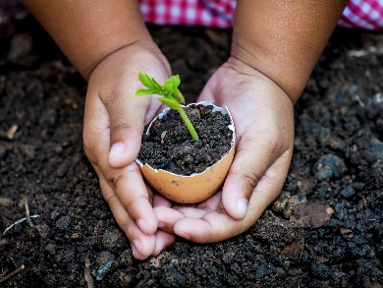 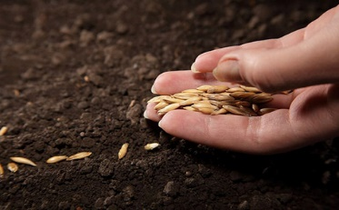 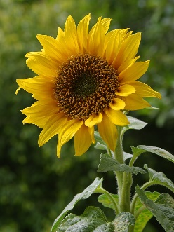

* Seed planting – over the course of the next few days all of the children will have brought home 5 sunflower seeds, chosen and counted by themselves. Let your child choose a spot in the garden, or a pot, where they would like to plant their seeds. Encourage them to make the hole for the seed, plant it and then water it. Encourage them to keep checking for any signs of growth and remind them of what they need to do to take care of it. (Alternatively put them in a pot on a sunny windowsill). Use words like ***sprout, roots, shoot, seedling, grow*** to explain to your child what is happening to the seed.
* Children love gardening so why not plant some other seeds or plants with them now the weather has warmed up. Ones which grow food are always popular! You would be surprised how even the fussiest eater will attempt a strawberry or pea which has been grown by themselves!