**Pre-school Play and Learning Newsletter for 17th – 21th June 2019**

* *Our wonder words this week have been: sailing boat, ferry, liner, dredger, house boat, cargo ship, hull, mast, sail, cabin
* **Play and Learning Highlights:**

We have continued with our theme of ‘Boats’ this week, with the addition of a new story ‘The Journey’ by Neil Griffiths, which we have used with the Flying Fish children. This story is about a lost boats journey and the different things it sails past before it finally reaches home. The story uses some lovely descriptive words and phrases and has been great for extending the children’s vocabulary. This story, together with ‘Mr Gumpy’s Outing’ (from last week) has inspired some super story telling – on paper in the form of pictures, small world play in the water tray and roleplay outside. All of these different forms of storytelling have provided the children with opportunities to develop their language skills to tell a tale from beginning to end. Oral story telling is so important for children, to express their imagination, to use language for a specific purpose and to practice what they will one day have to write (once at school). The richer their verbal vocabulary is the more descriptive and vivid their stories will be in the future.

Some great problem solving and physical skills have been observed during boat building activities. The children have used a variety of junk modelling to create boats which can float in the water tray and hold a specific number of animals. The children have had to learn how to attach pieces together, why boats need to be waterproof and how to get masts to stay upright. Not many were in a fit state to make it home as so much fun was had with sinking challenges but the learning and enjoyment that they had in the process was worth it!

**Out & About sessions:** Some sunshine at last! This week we have watched Portreath School’s Sports day, visited the little beach and built sand boats in teams to see whose could fit the most people in, and visited the reception class of Portreath School. On Friday we went out for the whole morning, creating and sailing boats from natural materials in the stream at Illogan Woods. It is so heartening to see how sensible and road safety aware the Flying Fish are on Out & Abouts as we end the year, plus their knowledge, interest and awareness of the local environment – clearly demonstrating all they have absorbed during these sessions throughout the year.

**Sounds and Letters/language focus:**



The Flying Fish have played initial letter sound games with all the letter sounds we have learnt so far this year. We have also been practising blending and segmenting cvc words and the children have been having a go at reading and writing them – skills they are very excited to try!

The Starfish have focused on the story ‘Mr Gumpy’s Outing’ and have used picture cards and small world characters to retell the story. They have also thought of warnings that Mr Gumpy could say to the animals before he lets them on to his boat, e.g. “You can only come on the boat if you don’t chase the pig”, “You can only come on the boat if you don’t make too much noise”. Their warnings have been very thoughtful and clearly linked to the book and the specific characters – clearly indicating how much they have absorbed of the story and its concepts.

**Ideas to support your child at home:**

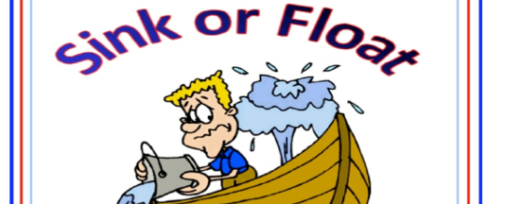**Floating and Sinking fun!**

The children have really enjoyed trying to make their boats sink or stay afloat in the water tray and predicting how many toy animals their boat will be able to carry without sinking. Your child could make a boat at home using junk modelling/duplo/lego etc and then see if it will float in the bath. Give them a variety of objects to play with in the bath but encourage them to predict if they think it will float or sink before they put it in the water. If your child is a little two year old model using the words ‘sinking’ and ‘floating’ to help extend their vocabulary and understanding of early science concepts.