**Pre-school Play and Learning Newsletter for 29th April– 3rd May 2019**

*Our wonder words this week have been: **extendable ladder, siren, hose, helmet, smoke alarm \***

**Play and Learning Highlights:**

The children have fully embraced the ‘firefighting’ theme this week with the addition of the borrowed uniforms inspiring some great group role play! The children have built fire engines from our blocks and tyres, worked out ways of getting water to different areas of the playground, worked as a team to put fires out and absorbed and used some technical ‘firefighting’ language. We have looked at and talked about the importance of smoke alarms, learnt the STOP, DROP and ROLL strategy for what to do if your clothes catch fire and talked about how to call for the fire service – all important things for little people to begin to understand in order to build their ‘keeping safe’ skills.

Other play and learning highlights include raking and planting our wildflower bed and runner bean den (fingers crossed they grow!), playing self-regulation games with bubbles (resisting the urge to pop them whilst they land on you – a VERY difficult urge to control we found!!), cleaning out the tadpoles and lots of outdoor fun with water, blocks, ramps and our friends.

**Out & About sessions:** It was with great enthusiasm and excitement that we were able to return to an old favourite place this week – Portreath Little Beach (as we call it). Now that the repairing of the wall has been completed the beach is once again a lovely safe open space for the children to use in a variety of ways. Counting was the focus this week, but the sessions quickly became outlets for physical challenges! We are so lucky that we are able to access environments which offer our little people the opportunity to participate in risky play. Watching them challenge themselves and confidently develop high levels of physical skills whilst sensibly risk assessing situations is a joy to observe and we feel very fortunate that our little people are able to experience these fundamental childhood thrills and joys in an age where so many aren’t.

**Sounds and Letters/language focus:**



The Flying Fish children have learnt the letter sounds ‘n’ and ‘f’ this week. We have played games with a fire engine putting out ‘f’ fires and generated ‘n’ words in our sound box. We have also focused the children’s attention on the way the n and m sound similar, but that our mouths make different shapes when we say them.

The Starfish have been playing ‘silly soup’ to help develop their awareness of what ‘rhyming’ means and which words rhyme. The aim of the game is to make a soup full of rhyming objects, e.g. cat, hat, bat, rat. We sing a funny nonsense rhyme whilst we make the soup too – one which the children find very amusing!

**Ideas to support your child at home:**

* *Even young children can be taught the importance of what to do if a fire ever broke out in their house. Show them where your smoke alarm is and talk about what they would do if it ever goes off (and it’s not due to burnt toast!). Talk to them about staying down low on the ground if there is lots of smoke and the*

*importance of getting outside as quick as possible.*

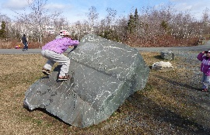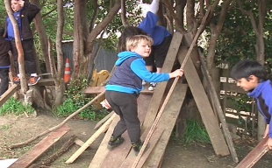

[This Photo](http://folksonomy.co/?permalink=3873) by Unknown Author is licensed under [CC BY-SA-NC](https://creativecommons.org/licenses/by-nc-sa/3.0/)

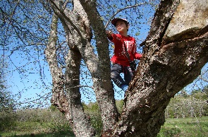

[This Photo](https://playgroundology.wordpress.com/category/risky-play/) by Unknown Author is licensed under [CC BY-SA-NC](https://creativecommons.org/licenses/by-nc-sa/3.0/)

* *The importance of ‘risky play’ in child development is becoming an increasingly talked about issue at the moment, with concerns over the high number of children who don’t have access to or opportunities to engage in these experiences. We are so lucky to have a wealth of local places which can provide children with the resources needed to allow them to climb, jump, crawl, run, balance, hang and challenge themselves physically. We, as parents and carers, need to ensure we allow them to take these calculated risks (whilst obviously keeping an eye on how sensible they are being). Try really hard to not say “Be careful” as this has been found to inhibit children before they have even started. Instead, try “Watch where you are putting your feet”, “Concentrate whilst you do it”, “Check that it’s safe before you start”, “Have you risk assessed it?” (good for older ones). Children, on the whole, are remarkably good at risk assessing, but only if they are given the opportunity to experience different challenges and situations.*