 | July 2018 |  |   This Photo by Unknown Author is licensed under CC BY-SA | Farewell Flying Fish! 
 |  |  | A very special Graduation celebration was held on Thursday to say ‘Goodbye and Good Luck’ to our lovely Fying Fish children. They have had a fantastic year and are going off to their ‘big schools’ with a great skill set and attitude to learning and new experiences. The staff and other children will miss them all very much! However we know that they are so ready and we wish them every success in this next big adventure in their lives. Please do keep in contact with us and let us know how they are getting on!
 | Our final newsletter of the 2017-18 academic year! What a great year we’ve had . . .
 | Thank very, very much!  All the staff would like to say a
HUGE thank you for our ‘Sunset Platter and Bubbles’ voucher we received from you all. Such a kind and generous gift! We are very much looking forward to using it!
Beach Day 2018
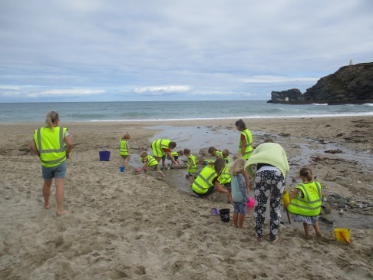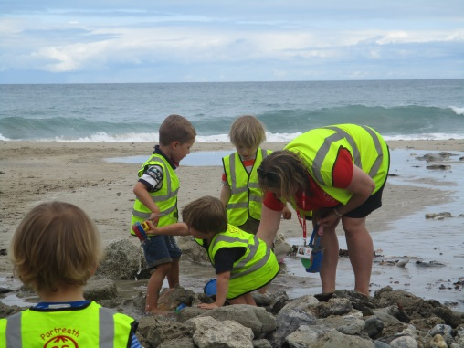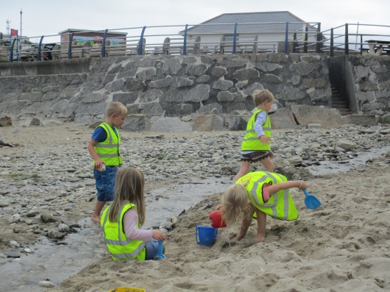
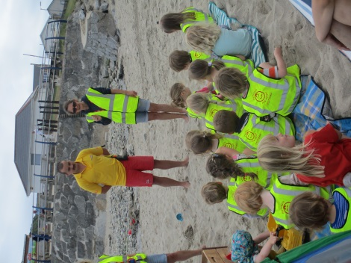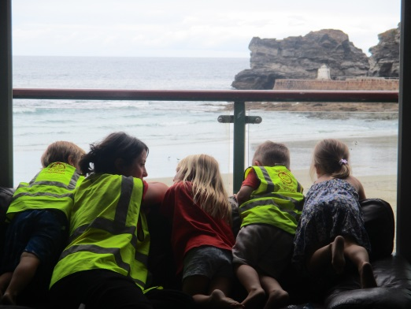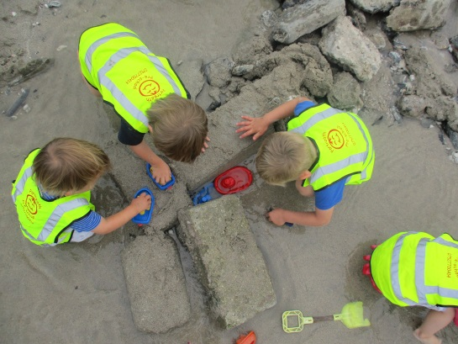
A great day was had by all last Tuesday – despite a few showers! The children enjoyed building dams and sandcastles, racing boats, learning about the different coloured flags from Matt the Lifeguard, drawing and storytelling, playing parachute games and running races. Thank you to the parents and grandparents who also came along on the day, we hope you enjoyed it too!
‘Out and About’ sessions
Our ‘Out and About’ sessions have proved to be a real success and we are planning on continuing and increasing them next year so that all our Flying Fish children regularly get the opportunity to have enriched learning experiences in our local community. We have seen this year how the children’s learning and confidence in themselves and their abilities has been deepened and inspired by the opportunities provided by being in different environments. If you happen to know of any walks or areas in Portreath that you think would be good experiences for the children, please do let us know.
Last week we visited the Atlantic Café for a toast and jam treat and the little beach for a sand castle building challenge, skimming stones games and mermaid creating; all whilst developing our mathematical, literacy, physical, social and communication skills, plus inspiring creativity and imagination!
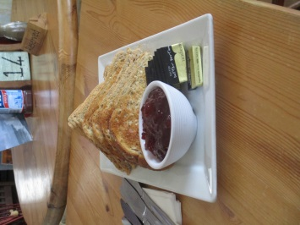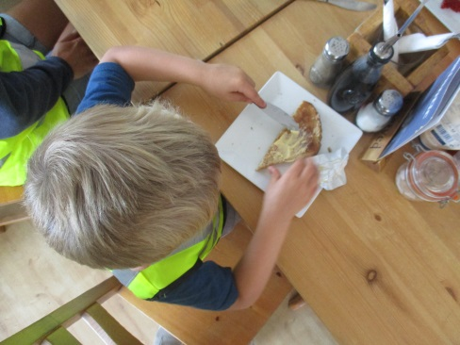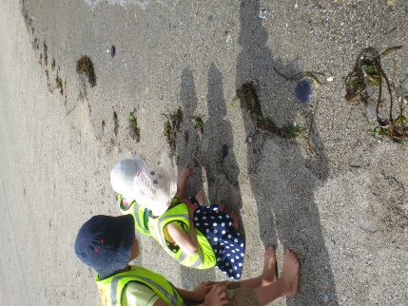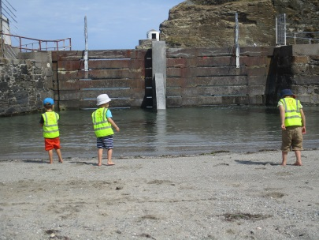
 |  | Marion and Peter Symonds from Portreath Bakery are celebrating 30 years of baking in Portreath. They have invited all the families from the pre-school to a special birthday celebration in The Harbour Association Hut in Portreath on Wednesday 1st August at 3pm for cream teas. Please do come along to join them and other members of the community.

The Summertime Sharing Books Challenge!

All of the children who will be returning in September have taken home a Summertime Sharing Books challenge to complete during the summer holidays. The idea is that they fill the boxes up with the titles of different stories/books they’ve had read to them over the course of the summer. If they return it to pre-school in September, with all the boxes filled, then they will receive a special certificate and sticker.

IMPORTANT DATES
Wednesday 1st August – Portreath Bakery birthday celebration
Thursday 6th September – Pre-school reopens.
INSED days for next academic year 2018-19 (Pre-school will be closed on these days) – Tues 4th and Wed 5th September, Friday 7th December, Friday 22nd March 2019, Thursday 25th July 2019 (this has changed from 1st July as originally planned – sorry!)

And lastly . . . 
This Photo by Unknown Author is licensed under CC BY-NC-ND
Thank you so much to all of you for your continued support and appreciation, we really wouldn’t be the pre-school we are without it! We feel very lucky to be able to support children in the heart of such a great community, with the backing and trust of families who really care about their children’s development. We wish you all a wonderful summer and look forward to seeing you in September for another year of learning and fun!

