 | May 2018 |  |  |  and   Some of you may have heard that sadly Alice will be leaving us in a couple of weeks’ time. Her family are in the process of purchasing a local business and she is leaving to go and work with them in this exciting enterprise. We will be extremely sad to see her go but wish her all the best for the next step in her future. She will be greatly missed!  By a lucky turn of events Natalie (who used to work with us) will be returning to pre-school to take Alice’s place. Many of you (and your children) will remember Natalie, and we are all delighted that she has chosen to return to pre-school!  Alice’s last day will be Thursday 17th May and Natalie’s first day will be Monday 21st May.
Hello! Just a quick newsletter to update you on some news and developments which have occurred over the last couple of weeks . . . .
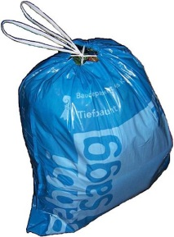  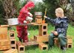 |  | Bags2School - A huge thank you to everyone who helped create a heavy load with their charity sacks – we raised £120! This will be going towards the new resources we wish to purchase for the outdoors area.
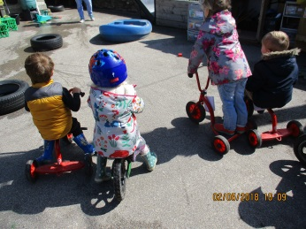 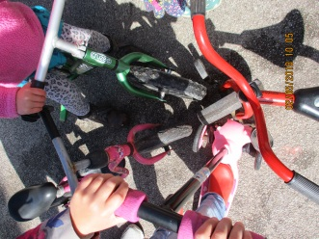 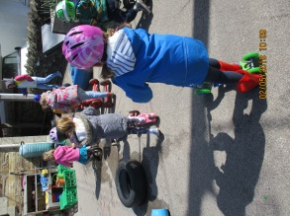Wheels, wheels, wheels!
The children have absolutely loved the focus on wheels, bikes and scooters. They have been riding their vehicles around the playground and demonstrated wonderful sharing and turn taking skills with their friends and their bikes/scooters. There have been many acts of kindness where children have offered other children, who didn’t have one, a go on their bike/scooter– a lovely gesture to see! We have used wheels to practice counting, calculating and comparing skills, create tally charts about how we got to school and developed our physical skills in using other people’s bikes and scooters around obstacle courses.
 |  |  | ECO FRIENDLY PRE-SCHOOL - In our bid to become more environmentally friendly we are trying to reduce our use of single use plastic bags. We are asking that each child has a reusable plastic bag in their rucksack for use to put wet clothes in. You can then put this back in to their bag after you’ve washed the clothes. This will greatly help the amount of nappy sacks we are using for this purpose.  We are now buying biodegradable wipes and nappy sack. They are costing a little more so we are trying to be as careful with them as possible!

‘Out and About’ sessions  On Wednesday the Flying Fish had an ‘Out and About’ session at the beach where they created roads in the sand for their cars and trucks to drive around. We witnessed problem solving and working cooperatively together whilst they worked on the challenge.  On Thursday we visited the park and the children had great fun developing their physical skills. We also played parachute games and made up stories about where our magical parachute could take us – some lovely imaginative ideas were given! |  | 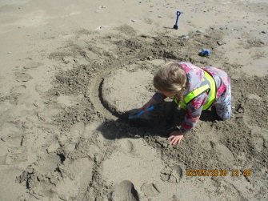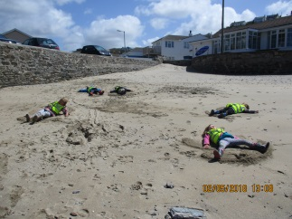  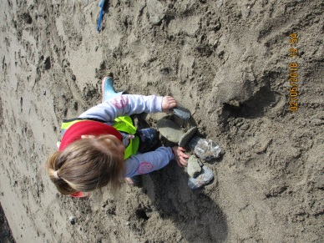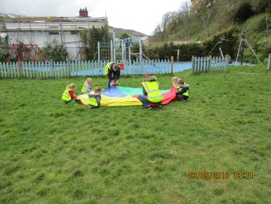
 | We are delighted to announce that Emma Bunt gave birth to a baby boy on 23rd April (same day as the new prince!). Jacob was born weighing in at 7lbs 13 & 1/2 ozs! Mummy and baby are doing well and Emma is looking forward to introducing him to the pre-school gang once she’s back on her feet.
IMPORTANT DATES:
Monday 7th May – Bank Holiday, pre-school will be closed.
Monday 21st May – Flying Fish group photo, 9 am at the pre-school.
Monday 28th – Friday 1st June – Half term, pre-school will be closed.
Wednesday 27th June (3 – 4pm) – Magic Garden picnic in aid of the NSPCC – details to follow after half term.
Monday 23rd July (6 pm) – Flying Fish Graduation Evening – details to follow after half term.
Tuesday 24th July – last day of term before summer holidays begin.
General Data Protection Regulations – Some of you may be aware that there are new date protection regulations coming into effect from May 25th. Clare and Rebekah have been busy ensuring the pre-school will be compliant with these regulations and as part of it will be asking you to fill in some new admission and consent forms. Please ask either Clare or Rebekah if you have any queries about this.

