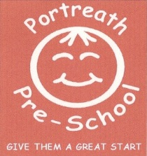 | September 2018 |  |  |  | 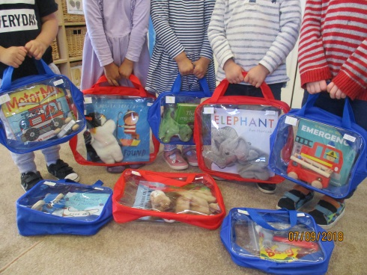  Home learning bags  We are so pleased with our investment in our new book bags and feel that they will greatly benefit your child’s language and early literacy skills. The children have responded with lots of enthusiasm to them and we hope you are enjoying sharing them at home. Further bags (suitable for the older children) will be added to the collection over the next few weeks, plus our other home learning bags too. Any feedback about these bags is greatly appreciated and we would love to know about any particular favourites of your child’s or any skills your child is developing through using them.
Hello! Where has September gone?! What a busy month we’ve had, welcoming back our old children and meeting and settling new little people into the pre-school family. We hope you are all feeling happy with how your children have settled back into the routine of coming to pre-school and know that you can talk to any of the staff about any concerns you have. We are here to help!
 |  | Unfortunately we have had to postpone the Social and Fundraising Evening due to low numbers of people who could attend. We are hoping to hold it November – a perfect time to buy some Xmas presents too! If you have any ideas for social evenings or a fundraising event please do tell us!
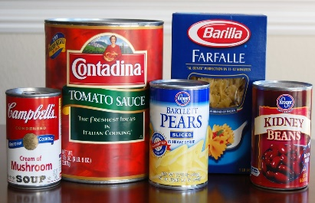 |  |  | Harvest Time Foodbank collection – over the next couple of weeks we will be talking to the children about harvest time and the tradition of giving food to people who don’t have enough. We would like to do a collection for the local foodbank, so are asking for any donations over the next two weeks. Mandy Goldring, the coordinator of the ‘Saturday Food Drop’ foodbank, is grateful for any donations of tins, jars and dried food, e.g. tinned meat/fish, tins of custard, rice pudding, packets of pasta, rice, tinned vegetables and fruit etc. Please bring any donations in by Friday 12th October 2018.
 |  |  | Please remember to put a reusable bag in your child’s bag for us to put wet clothes in. The children have been very keen to engage in water play so we are tending to have a lot of wet changes of clothes at the moment!
Exciting news! We have just been accepted on to the Healthy Under 5s programme. This is a new project created by Cornwall County Council focusing on early years settings becoming health promoting environments. The topics covered are: Dental Health, Healthy Eating, Physical Activity, Emotional Health and Wellbeing, Accident Prevention, plus other topics. We will be working to promote and support these topics with your child at pre-school, plus providing information for you to use at home also. Our aim is to achieve the Healthy Under 5s recognition during the course of this academic year.
Out and About’ sessions  The Flying Fish children are being introduced to these sessions in small groups at the moment so that we can teach them about how to keep safe whilst we are outside of pre-school, plus focusing on their listening and following instructions skills. The trips are usually weather dependent but we are hoping that unless it is severely windy/rainy we will be able to go out throughout the autumn and winter. For this reason we ask that your child has a coat in their bag at all times as the weather can often change very quickly! |  |  |  | 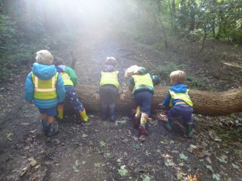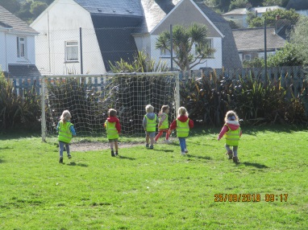  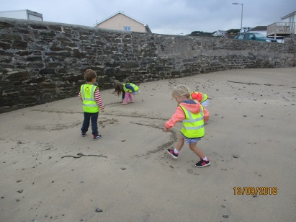
Parent Open Evening – Wednesday 17th October 2018, 7pm Come along to have an informal chat about how your child has settled. The evening will open with a talk about how to support your child’s literacy and mathematical development, plus you can see some of the resources we use to enhance this at pre-school. Please let one of the staff know if you are able to attend.
IMPORTANT DATES:
Friday 12th October – Food bank donations to be collected.
Wednesday 17th October – 9 am Tempest photography in for individual photos. Please bring along siblings too if you would like them to be photographed together.
Wednesday 17th October – 7pm Parents Open Evening and Literacy/Maths Workshop
Monday 22nd October – Friday 26th October – Half term, pre-school will be closed.

