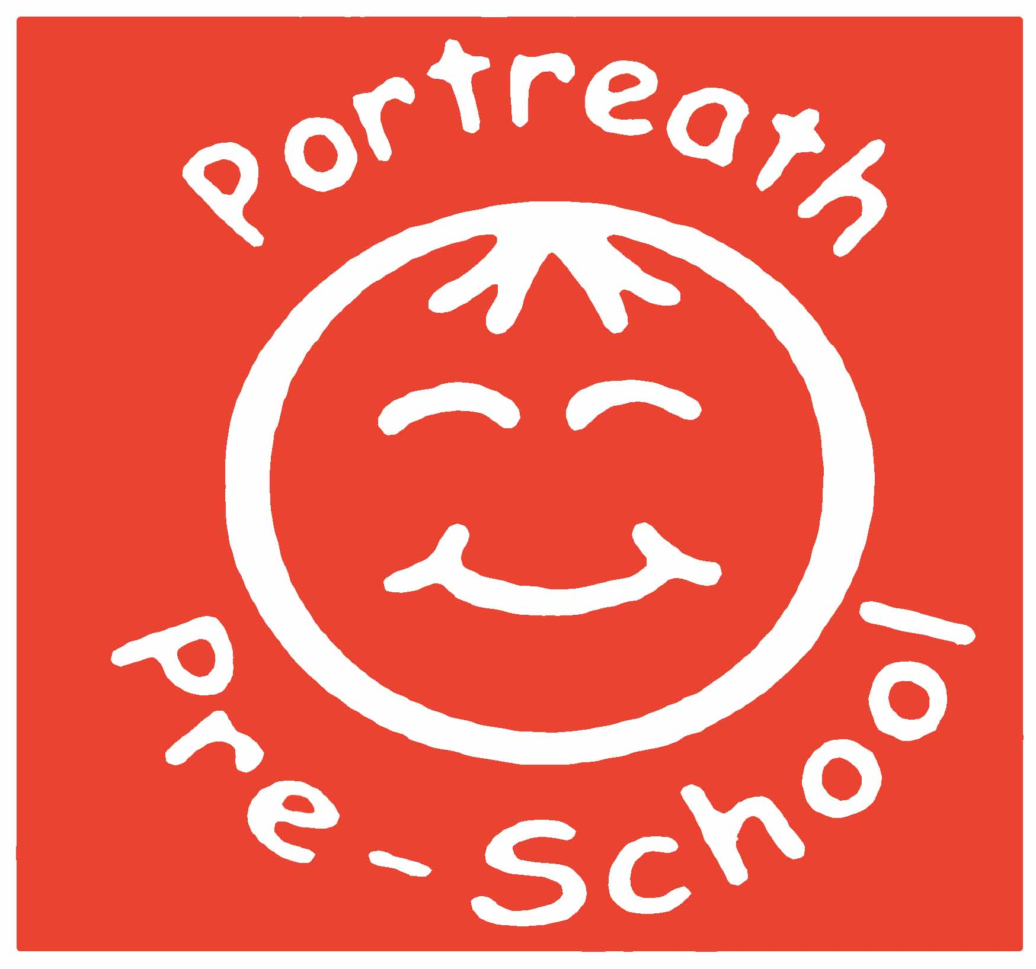 **Children’s rights and entitlements**

Every child deserves the best possible start in life and the support that enables them to fulfil their potential. Children develop quickly in the early years and a child’s experiences between birth and age five have a major impact on their future life chances. A secure, safe and happy childhood is important in its’ own right. Good parenting and high quality early learning together provide the foundation children need to make the most of their abilities and talents as they grow up

The EYFS seeks to provide:

* **quality and consistency** in all early years settings, so that every child makes good progress and no child gets left behind
* **a secure foundation** through learning and development opportunities which are planes around the needs and interests of each individual child and are assessed and reviewed regularly
* **partnership working** between practitioners and with parents and/or carers
* **equality of opportunity** and anti-discriminatory practice, ensuring that every child is included and supported

The EYFS specifies requirements for learning and development and for safeguarding children and promoting their welfare. The **learning and requirements** cover:

* the **areas of learning and development** which must shape activities and experiences **(educational programmes)** for children in all early years settings
* the **early learning goals** that providers must help children work towards (the knowledge, skills and understanding children should have at the end of the academic year in which they turn five)
* **assessment arrangements** for measuring progress (and requirements for reporting to parents and/or carer)

Four guiding principles should shape practice in early years settings. These are:

• Every child is a **unique child**, who is constantly learning and can be resilient, capable, confident and self-assured;

• Children learn to be strong and independent through **positive relationships**;

• Children learn and develop well in **enabling environments**, in which their experiences respond to their individual needs and there is a strong partnership between practitioners and parents and/or carers; and

• **Children develop and learn in different ways and at different rates**. The framework covers the education and care of all children in early years provision, including children with special educational needs and disabilities. In planning and guiding children’s activities, practitioners must reflect on the different ways that children learn and reflect these in their practice. Three characteristics of effective teaching and learning are:

* **playing and exploring** – children investigate and experience things, and ‘have ago’
* **active learning** – children concentrate and keep on trying if they encounter difficulties, and enjoy achievements
* **creating and thinking critically** – children have and develop their own ideas, make links between ideas, and develop strategies for doing things

(EYFS 2024)

We also understand our role in protecting the rights of our children according to the UN convention on The Rights of a Child (A summary of the rights under the Convention

on the Rights of the Child**)** <https://www.unicef.org.uk/wp-content/uploads/2019/10/UNCRC_summary-1_1.pdf>

We adapt our practice to uphold all children’s rights including Article 12 (Respect for the views of the child): When adults are making decisions that affect children, children have the right to say what they think should happen and have their opinions taken into account. We endeavour to involve our children in our decision making process, taking into account their stage of development.

We will uphold the right for our children to become ***strong, capable, resilient and listened to.***

**Policy statement**

* We promote children's right to be *strong, capable, resilient and listened to* by creating an environment in our setting that encourages children to develop a positive self- image, which includes their heritage arising from their colour and ethnicity, their languages spoken at home, their religious beliefs, cultural traditions and home background.
* We promote children's right to be *strong, capable, resilient and listened to* by encouraging children to develop a sense of autonomy and independence.
* We promote children's right to be *strong, capable, resilient and listened to* by enabling children to have the self-confidence and the vocabulary to resist inappropriate approaches.
* We help children to establish and sustain satisfying relationships within their families, with peers, and with other adults.
* We work with parents to build their understanding of, and commitment to, the principles of safeguarding all our children.

**What it means to promote children’s rights and entitlements to be ‘*strong, capable, resilient and listened to’.***

To be **strong** means to be:

* **secure** in their foremost attachment relationships where they are loved and cared for, by at least one person who is able to offer consistent, positive and unconditional regard and who can be relied on;
* **safe and valued** as individuals in their families and in relationships beyond the family, such as in their early years setting/day care;
* **self assured** and form a positive sense of themselves – including all aspects of their identity and heritage;
* **included equally and belong** in early years settings and in community life;
* **confident in abilities** and **proud** of their achievements**;**
* **progressing optimally** in all aspects of their development and learning;
* **to be part of a peer group** in which to learn to negotiate, develop social skills and identity as global citizens, respecting the rights of others in a diverse world; and
* **to participate and be able to represent themselves** in aspects of service delivery that affects them as well as aspects of key decisions that affect their lives.

To be r**esilient** means to:

* **be sure** of their self worth and dignity;
* be able to be **assertive** and state their needs effectively;
* be able to **overcome** difficulties and problems;
* **be positive** in their outlook on life;
* be able to **cope** with challenge and change;
* have a **sense of justice** towards self and others;
* to develop a **sense of responsibility** towards self and others; and
* to be able to **represent** themselves and others in key decision making processes.

To be **listened to** means:

* adults who are close to children recognise their need and **right to express and communicate** their thoughts, feelings and ideas;
* adults who are close to children are able to **tune in** to their verbal, sign and body language in order to understand and interpret what is being expressed and communicated;
* adults who are close to children are able to **respond appropriately and, when required, act upon their understanding** of what children express and communicate ; and
* adults **respect children’s rights** and **facilitate children’s participation** **and** **representation** in imaginative and child centred ways in all aspects of core services.

**Capable** children will have the skills needed to help them become life- long learners. They will be ready for the next step in their learning journey-school.

|  |  |  |
| --- | --- | --- |
| This policy was adopted at a meeting of | Portreath Pre-School |  |
| Held on | 09.02.2017 |  |
| Last review date: | 24.04.24 – reviewed and amended |  |