Play & Learning Newsletter

8-12th July 2024

**Pirate, treasure, Ahoy matey, compass, rigging, hook**

Wonder words to use with your child:

Ahoy me hearties!! There be pirates in pre-school this week – and cheeky ones at that! The children have enjoyed the start to our pirate theme this week, with lots of imaginative roleplay in the pirate’s galley kitchen, finding and counting treasure in the water tray and sand tray (and then hiding it in various places in the pre-school!), imaginative ways of cheering up the grumpy pirate during our sea shanty singing sessions and developing physical skills whilst taking part in pirate exercises, creating pirate maps and listening to and talking about pirate stories. As the children are so engaged we will be continuing with our pirate theme next week!

Treasure maps have been very popular, and many children have chosen to create their own ones, using teabags and scrunching to make them look realistic. ‘X marks the spot’ has also been a very frequently used phrase, with it providing a super opportunity for inspiring some mark making.

***Sounds and Letters/language focus:***



The Flying Fish have been consolidating all the phonic skills we have covered over the past year, through games and focused activities. The children have particularly enjoyed playing the ‘I SPY’ activity where they had to listen to word endings in CVC words.

This week we used the book ’10 Little Pirates’ in our Star fish group times sessions – a great book for talking about one less and supporting children’s understanding of numbers to 10. We spent lots of time discussing the various ways the little pirates disappeared

 **Out & About sessions:**

On Monday we planned our teddy bears picnic at Harbour house. They made decorations with the residents and made invitations for people to attend.

The Flying Fish have really enjoyed going on treasure hunts this week at the woods, where they found a treasure chest with lots of gold coins. They were so excited to show their friends and on Friday they very kindly returned the treasure back to the pirates.

On Thursday the Flying Fish had a very exciting time at the allotment where they got to harvest their potatoes and peas after looking after them for many weeks.

Friday we had a group attend forest school where they were on their bug hunting mission and enjoyed many activities and snack at base camp.

Ideas to support your child at home:

 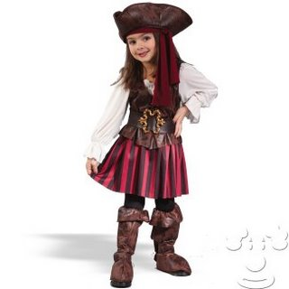

Use this week’s focus on pirates to set your child some challenges. Can your child build an obstacle course for a pirate? Can they make a little garden for a pirate in their garden? Encourage your child to explain what each part of their creation is about and how they think the pirate could use it.